Sleep Sync Application Documentation

1. Introduction
Sleep Sync is a web-based application that helps users track their sleep, earn XP based on sleep duration, unlock badges, maintain streaks, and visualize progress. It includes features such as reminders, theme customization, XP tiers, and data persistence using localStorage.

2. Features
• Log sleep duration and optional bedtime.
• Earn XP: 10 XP per hour of sleep + streak bonuses.
• Automatic streak tracking and streak-based XP rewards.
• XP tiers (Bronze, Silver, Gold, Platinum, Diamond, Master).
• Unlockable badges based on sleep habits and XP milestones.
• Pie-chart visual for sleep duration.
• Themes (Default, Night, Sunny).
• Reminder system with history logging.
• LocalStorage-based data saving.

3. XP System
• XP is earned as 10 XP per hour of sleep.
• Streak continuation gives an extra +50 XP.
• Tiers are determined by XP:
- Bronze – 0 XP
- Silver – 200 XP
- Gold – 500 XP
- Platinum – 900 XP
- Diamond – 1400 XP
- Master – 2000 XP

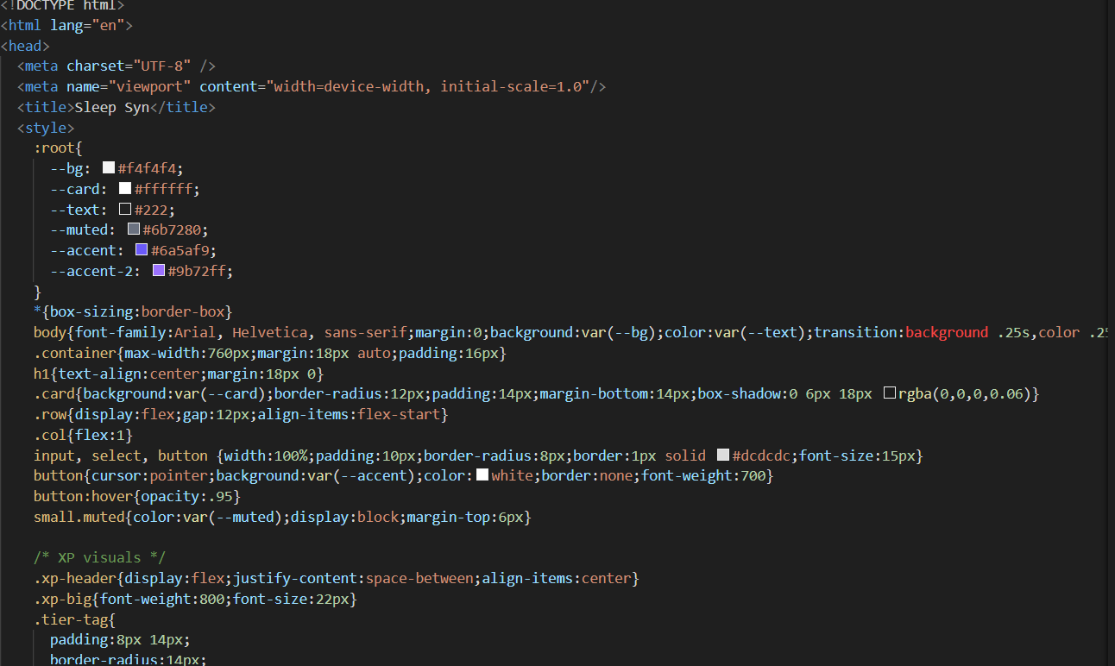

4. Badges
Badges are awarded automatically based on recent activity and XP milestones.
• Early Bird – Bedtime ≤ 22:00
• Night Owl – Bedtime ≥ 23:00 or before 03:00
• Healthy Sleep – Sleep ≥ 8 hours
• Power Sleeper – Sleep ≥ 9 hours
• Sleep Legend – Sleep ≥ 10 hours
• Streak Master – Maintain a 7‑day streak
• Marathon Sleeper – Sleep ≥ 12 hours once
• Calm Mind – Improve by ≥ 1 hour compared to previous day
• Recovery Mode – Recover from low sleep (<5h → ≥7h)
• XP‑based badges: 0 XP, 100 XP, 300 XP, 600 XP, 1000 XP

5. UI Components
• Sleep logging card with inputs for sleep hours and bedtime.
• XP dashboard with progress bar and tier indicator.
• Pie chart showing sleep duration percentage out of 12 hours.
• Badge grid showing locked and unlocked badges.
• Theme selector with dynamic UI updates.

• Reminder system with history logging.

6. Data Storage
All data is stored locally in the browser's localStorage under the key 'sleepsync_opt2_state_v1'. The stored state includes XP, streaks, badges, entries, reminders, and theme preferences.

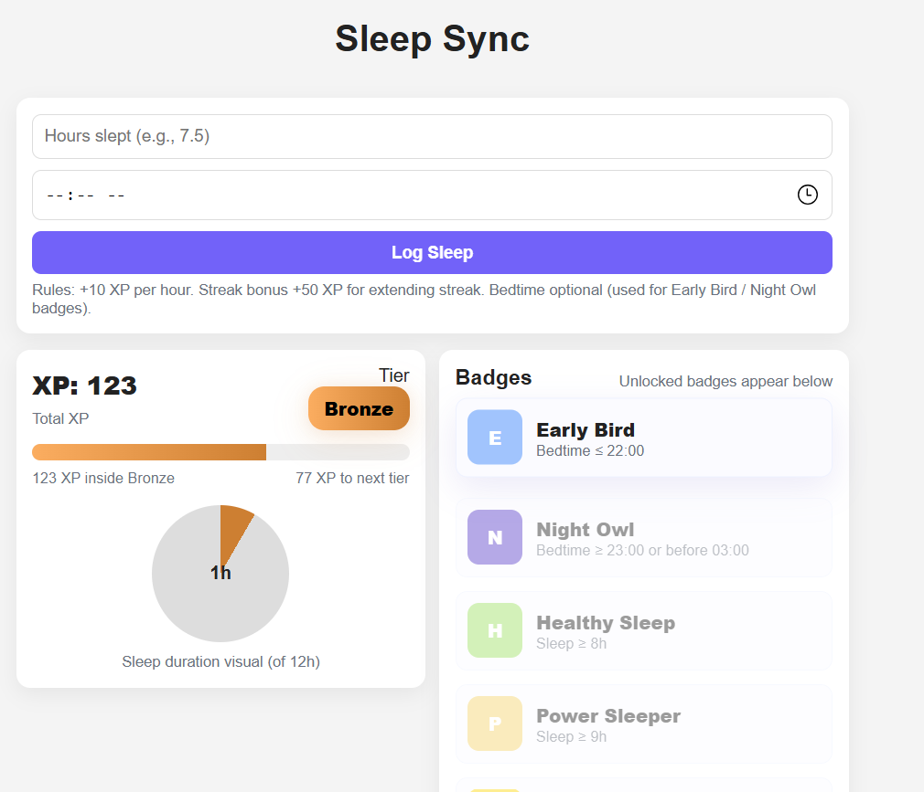

7. JavaScript Functional Flow
• Initialization: loads saved state and renders UI.
• Logging Sleep: calculates XP, updates streak, evaluates badges, updates visuals.
• Tier Calculation: determines tier, progress within tier, and XP to next tier.
• Badge Checking: evaluates conditions and unlocks badges dynamically.
• UI Rendering: updates XP bar, pie chart, badges, and reminders.
• Theme Handling: applies light/dark/sunny themes.
• Reminder System: schedules alerts and saves history.

8. Conclusion
This documentation outlines the working structure, features, and logic of the Sleep Sync application. It provides an organized view useful for project submission, understanding the codebase, or further development.

